

05 - List in Python

Department of Computer Science and Engineering

| Rajalakshmi Engineering College

PA. GE

Ex. No. : 5.1 Date: 25.04.2024

Register No.: 231401020 Name: BHUVANESWARI

Balanced Array
Given an array of numbers, find the index of the smallest array element (the pivot), for which the sums of all elements to the left and to the right are equal. The array may not be reordered.

Example
arr=[1,2,3,4,6]

· the sum of the first three elements, 1+2+3=6. The value of the last element is 6.
· Using zero based indexing, arr[3]=4 is the pivot between the two subarrays.

· The index of the pivot is 3.
Constraints

· 3 ≤ n ≤ 105
· 1 ≤ arr[i] ≤ 2 × 104, where 0 ≤ i < n

· It is guaranteed that a solution always exists.
The first line contains an integer n, the size of the array arr. Each of the next n lines contains an integer, arr[i], where 0 ≤ i < n. Sample Case 0

Sample Input 0
4

1
2

3
3

Sample Output 0
2

Explanation 0
The sum of the first two elements, 1+2=3. The value of the last element is 3

Using zero based indexing, arr[2]=3 is the pivot between the two subarrays
The index of the pivot is 2

Sample Case 1
Sample Input 1

3
1

2
1

Sample Output 1
1

Explanation 1
The first and last elements are equal to 1

Department of Computer Science and Engineering | Rajalakshmi Engineering College

PA.

GE

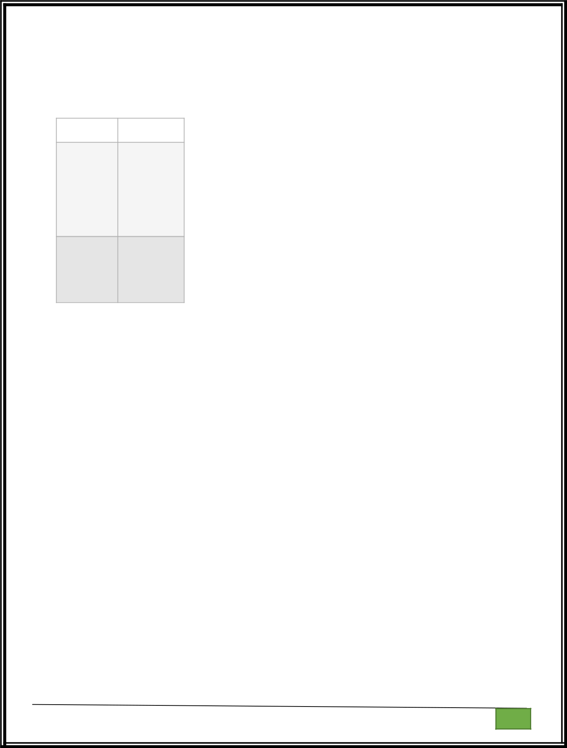
Using zero based indexing, arr[1]=2 is the pivot between the two subarrays The index of the pivot is 1.

For example:

Input | Result

- 2
1

2
3

3

- 1

1
2

1

a=int(input())

l=[]

for i in range(a):

c=int(input())

l.append(c)

for i in range(1,a):

d=sum(l[0:i])

r=sum(l[i+1:])

if(d==r):

print(i)

Department of Computer Science and Engineering | Rajalakshmi Engineering College

PA.

GE

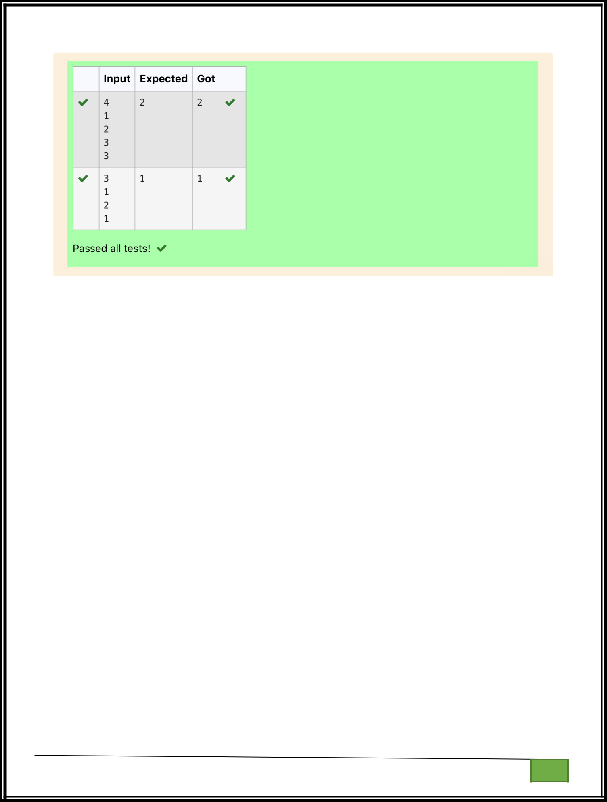

Department of Computer Science and Engineering

| Rajalakshmi Engineering College

PA. GE

Department of Computer Science and Engineering

| Rajalakshmi Engineering College

PA. GE
Ex. No. : 5.2 Date: 25.04.2024

Register No.: 231401020 Name: BHUVANESWARI

Check pair with difference k
Given an array A of sorted integers and another non negative integer k, find if there exists 2 indices i and j such that A[i] - A[j] = k, i != j.

Input Format

1. First line is number of test cases T. Following T lines contain:
2. N, followed by N integers of the array

3. The non-negative integer k
Output format

Print 1 if such a pair exists and 0 if it doesn’t Input

1
3

1
3

5
4

Output:
1

Input
1

3
1

3
5

99
Output

0

For example:

Input | Result
1 | 1
3
1
3
5
4

Department of Computer Science and Engineering | Rajalakshmi Engineering College

PA.

GE

Input

Result
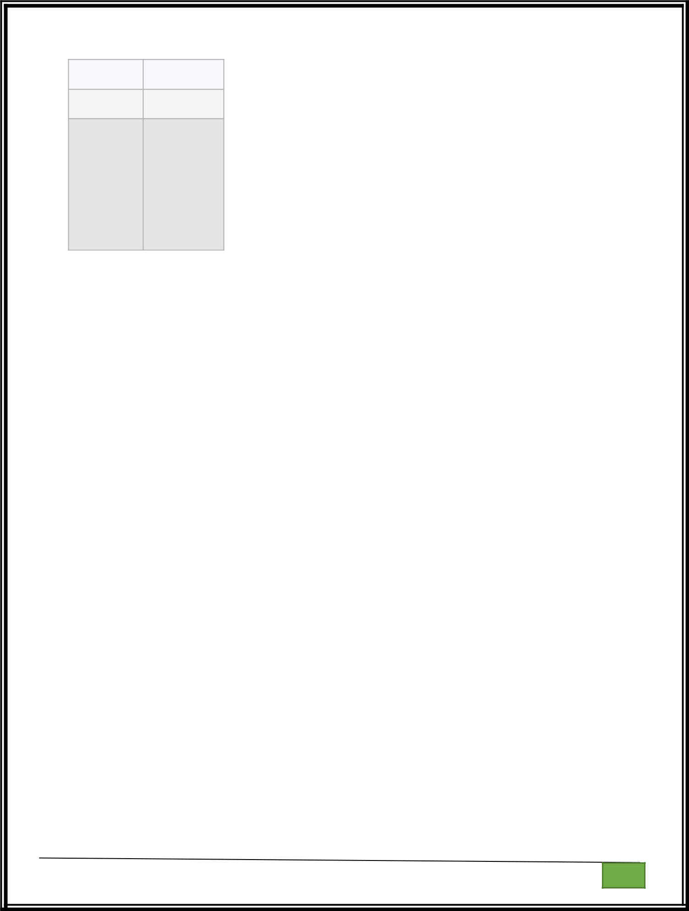

1

3
1

3
5

99

0

a=int(input())
while(a!=0):

b=int(input())
l=[]

f=0
for i in range(b):

c=int(input())
l.append(c)

k=int(input())
a-=1

for i in range(b):
for j in range(b):

if(l[i]-l[j]==k and i!=j):

f=1

break
if(f==1):

print(1)
else:

print(0)

Department of Computer Science and Engineering

| Rajalakshmi Engineering College

PA. GE

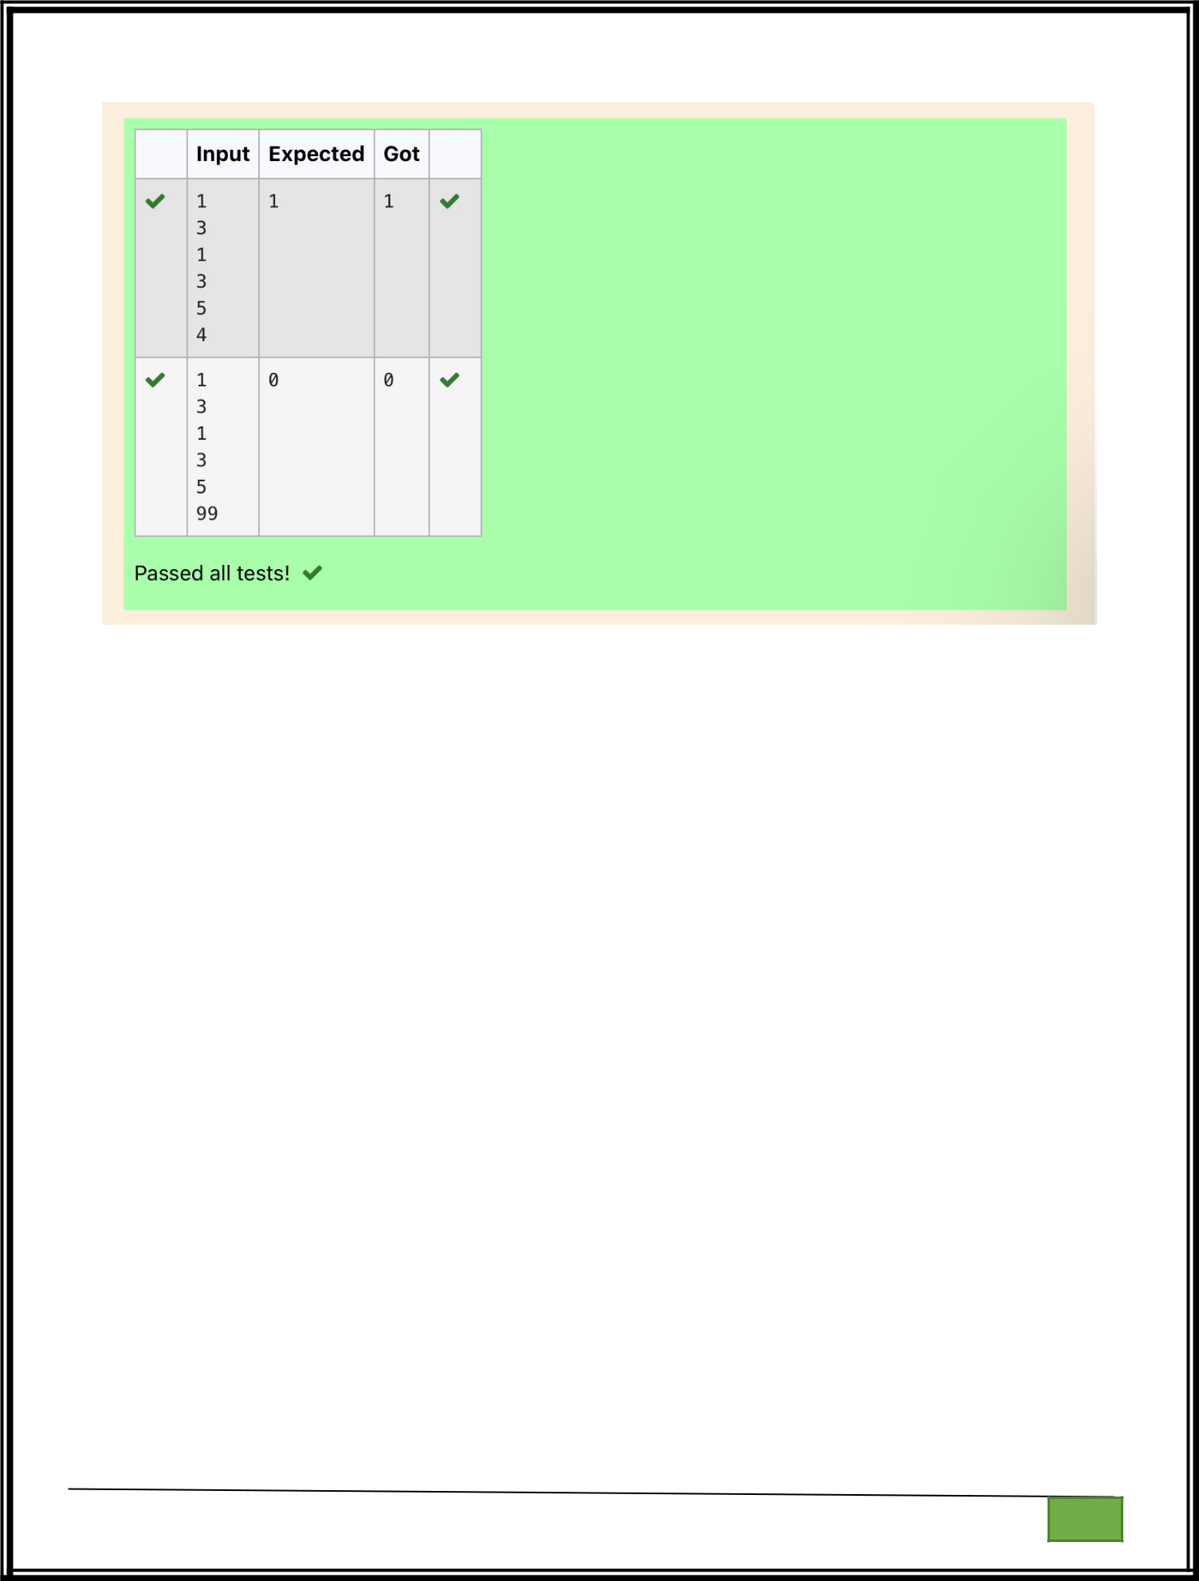

Department of Computer Science and Engineering

| Rajalakshmi Engineering College

PA. GE

Department of Computer Science and Engineering

| Rajalakshmi Engineering College

PA. GE
Ex. No. : 5.3 Date: 25.04.2024

Register No.: 231401020 Name: BHUVANESWARI

Count Elements
Complete the program to count frequency of each element of an array. Frequency of a particular element will be printed once.

Sample Test Cases

Test Case 1

Input

7

23

45

23

56

45

23

40

Output

23 occurs 3 times

45 occurs 2 times

56 occurs 1 times

40 occurs 1 times

import collections

def CountFrequency(arr):

return collections.Counter(arr)

Department of Computer Science and Engineering | Rajalakshmi Engineering College

PA.

GE

if __name__ == "__main__":

- Input size of array n = int(input())

- Input elements in array arr = []
for _ in range(n): ele = int(input()) arr.append(ele)

- Calculate frequency of each element freq = CountFrequency(arr)

for key, value in freq.items():

print(f"{key} occurs {value} times")

Department of Computer Science and Engineering | Rajalakshmi Engineering College

PA.

GE

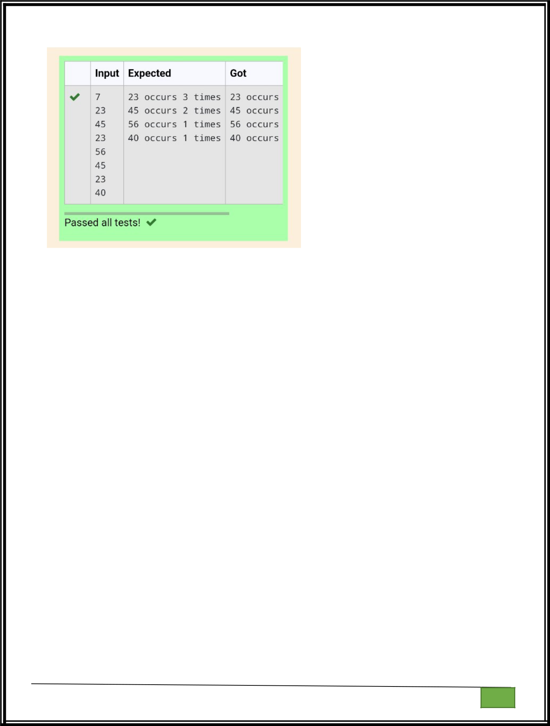

Department of Computer Science and Engineering

| Rajalakshmi Engineering College

PA. GE

Department of Computer Science and Engineering

| Rajalakshmi Engineering College

PA. GE
Ex. No. : 5.4 Date: 25.04.2024

Register No.: 231401020 Name: BHUVANESWARI

Distinct Elements in an Array
Program to print all the distinct elements in an array. Distinct elements are nothing but the unique (non-duplicate) elements present in the given array.

Input Format:

First line take an Integer input from stdin which is array length n.
Second line take n Integers which is inputs of array.

Output Format:
Print the Distinct Elements in Array in single line which is space Separated

Example Input:

5
1

2
2

3
4

Output:
1234

Example Input:
6

1
1

2
2

3
3

Output:
1 2 3

For example:

Input Result
5

1
2

2
3

4
1234

6

Department of Computer Science and Engineering | Rajalakshmi Engineering College

PA.

GE

1
1

2
2

3
3

1 2 3

def merge_arrays_without_duplicates(arr1, arr2):

- Combine the arrays and convert to a set to remove duplicates result_set = set(arr1 + arr2)
- Convert the set back to a sorted list

merged_sorted_array = sorted(result_set)

return merged_sorted_array

- Input read and processing def process_input():
  - Reading number of elements and the elements for the first array n1 = int(input())
array1 = []

for _ in range(n1): element = int(input()) array1.append(element)

  - Reading number of elements and the elements for the second array n2 = int(input())
array2 = []

Department of Computer Science and Engineering | Rajalakshmi Engineering College

PA.

GE

for _ in range(n2):

element = int(input())

array2.append(element)

# Merge the arrays without duplicates

result = merge_arrays_without_duplicates(array1, array2)

# Print the result

print(" ".join(map(str, result)))

Department of Computer Science and Engineering | Rajalakshmi Engineering College

PA.

GE

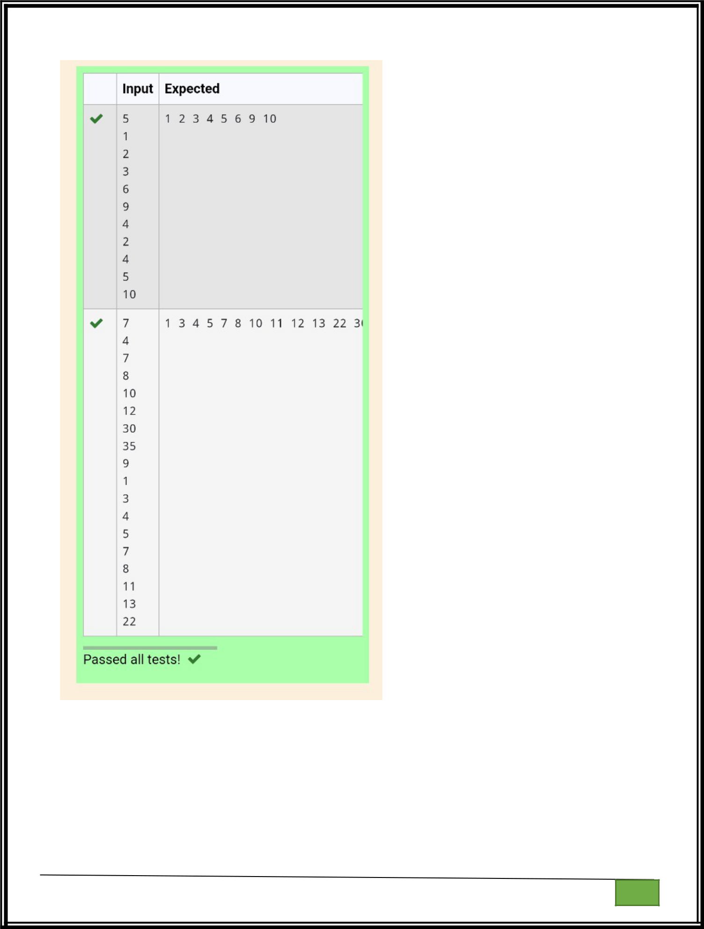

Department of Computer Science and Engineering

| Rajalakshmi Engineering College

PA. GE

Department of Computer Science and Engineering

| Rajalakshmi Engineering College

PA. GE
Ex. No. : 5.5 Date: 25.04.2024

Register No.: 231401020 Name: BHUVANESWARI

Element Insertion
Consider a program to insert an element / item in the sorted array. Complete the logic by filling up required code in editable section. Consider an array of size 10. The eleventh item is the data is to be inserted.

Sample Test Cases | 11
Test Case 1 | 22
Input | 33
1 | 55
3 | 66
4 | 77
5 | 88
6 | 99
7 | 110
8 | 120
9 | 44
10 | Output
11 | Output
2 | ITEM to be inserted:44
Output | After insertion array is:
ITEM to be inserted:2 | 11
After insertion array is: | 22
1 | 33
2 | 44
3 | 55
4 | 66
5 | 77
6 | 88
7 | 99
8 | 110
9 | 120
10
11

 | def insert_sorted(list, n):
Test Case 2 | list.append(n)
Input

Department of Computer Science and Engineering | Rajalakshmi Engineering College

PA.

GE

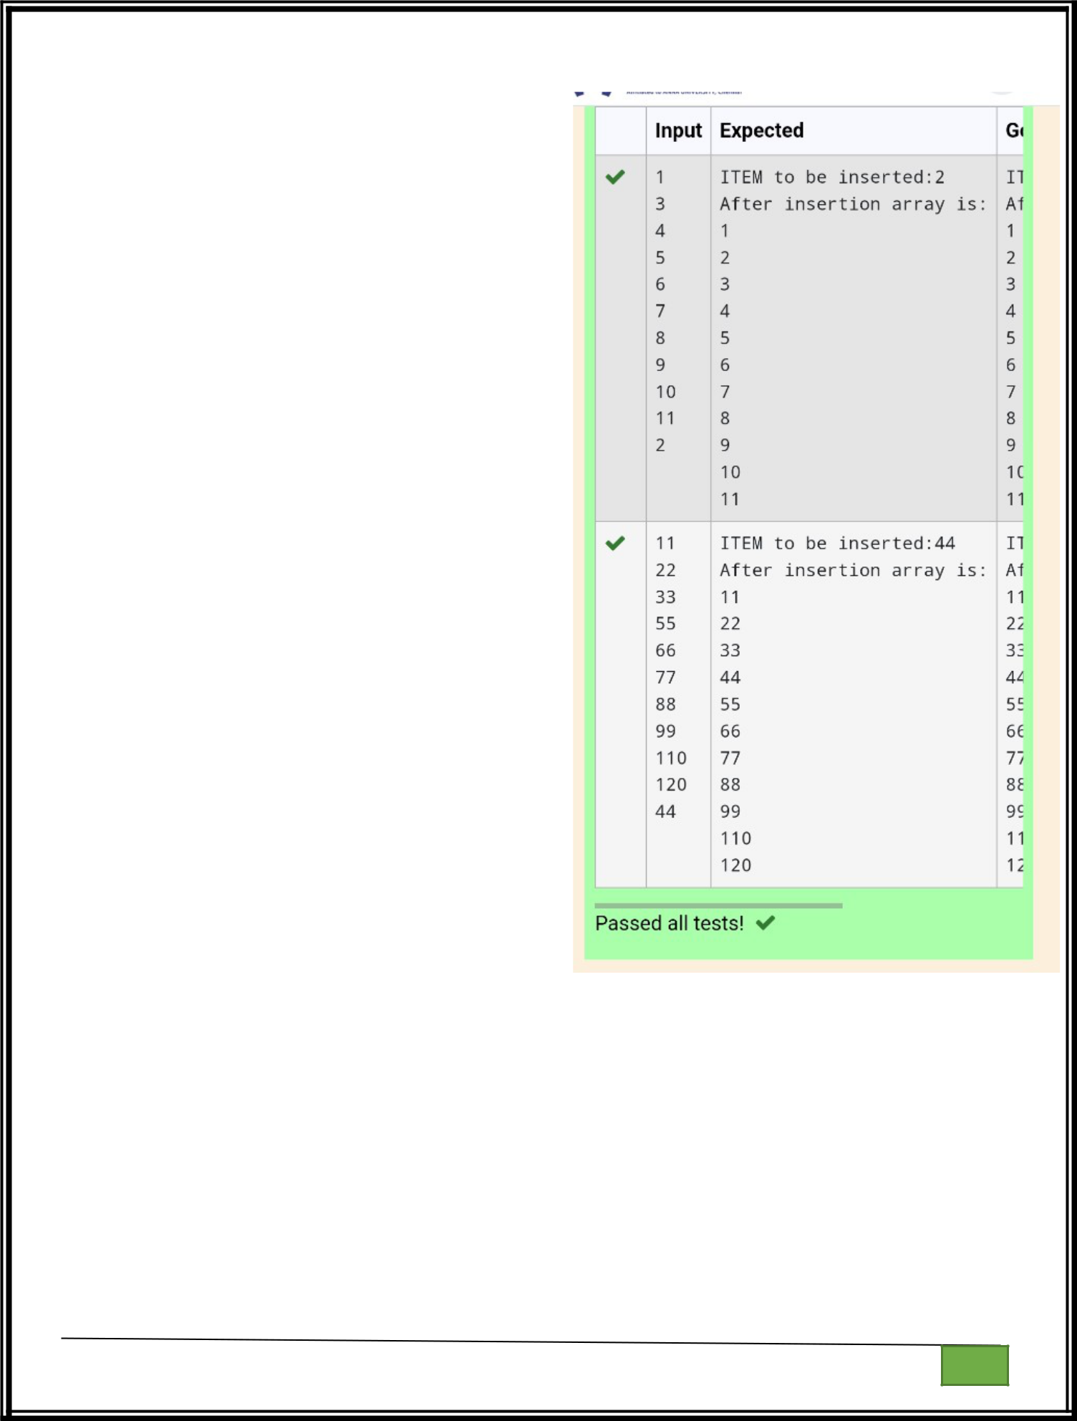
sorted_list = sorted(list) print("After insertion array is:") for i in range(11):

print(sorted_list[i])

sorted_list = [int(input()) for i in range(10)]

new_element = int(input())

print("ITEM to be inserted:", new_element, sep='')

insert_sorted(sorted_list, new_element)

Department of Computer Science and Engineering | Rajalakshmi Engineering College

PA.

GE

Department of Computer Science and Engineering

| Rajalakshmi Engineering College

PA. GE
Ex. No. : 5.6 Date: 25.04.2024

Register No.: 231401020 Name: BHUVANESWARI

Find the Factor
Determine the factors of a number (i.e., all positive integer values that evenly divide into a number) and then return the pth element of the list, sorted ascending. If there is no pth element, return 0.

Constraints

- ≤ n ≤ 1015

- ≤ p ≤ 109

The first line contains an integer n, the number to factor.

The second line contains an integer p, the 1-based index of the factor to return.

Sample Case 0
Sample Input 0
10
3

Sample Output 0
5

Explanation 0
Factoring n = 10 results in {1, 2, 5, 10}. Return the p = 3rd factor, 5, as the answer.

Sample Case 1
Sample Input 1

10

5

Sample Output 1
0

Explanation 1
Factoring n = 10 results in {1, 2, 5, 10}. There are only 4 factors and p = 5, therefore 0 is returned as the answer.

Sample Case 2
Sample Input 2
1
1

Sample Output 2
1

Explanation 2
Factoring n = 1 results in {1}. The p = 1st factor of 1 is returned as the answer.

Department of Computer Science and Engineering | Rajalakshmi Engineering College

PA.

GE

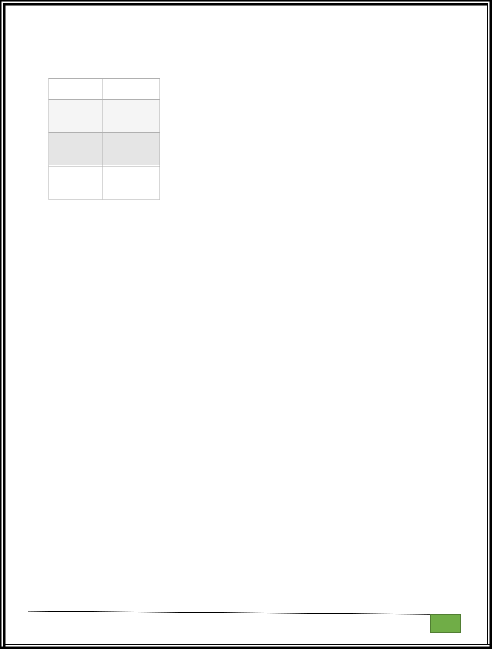

For example:

Input | Result

- 5
3

- 0

5

1 | 1
1

import sys

import math

def find_factors(n):

factors = []

for i in range(1, int(math.sqrt(n)) + 1):

if n % i == 0:

factors.append(i)

if i != n // i:

factors.append(n // i)

return sorted(factors)

def get_pth_factor(n, p):

factors = find_factors(n)

if p <= len(factors):

return factors[p - 1]

else:

Department of Computer Science and Engineering | Rajalakshmi Engineering College

PA.

GE

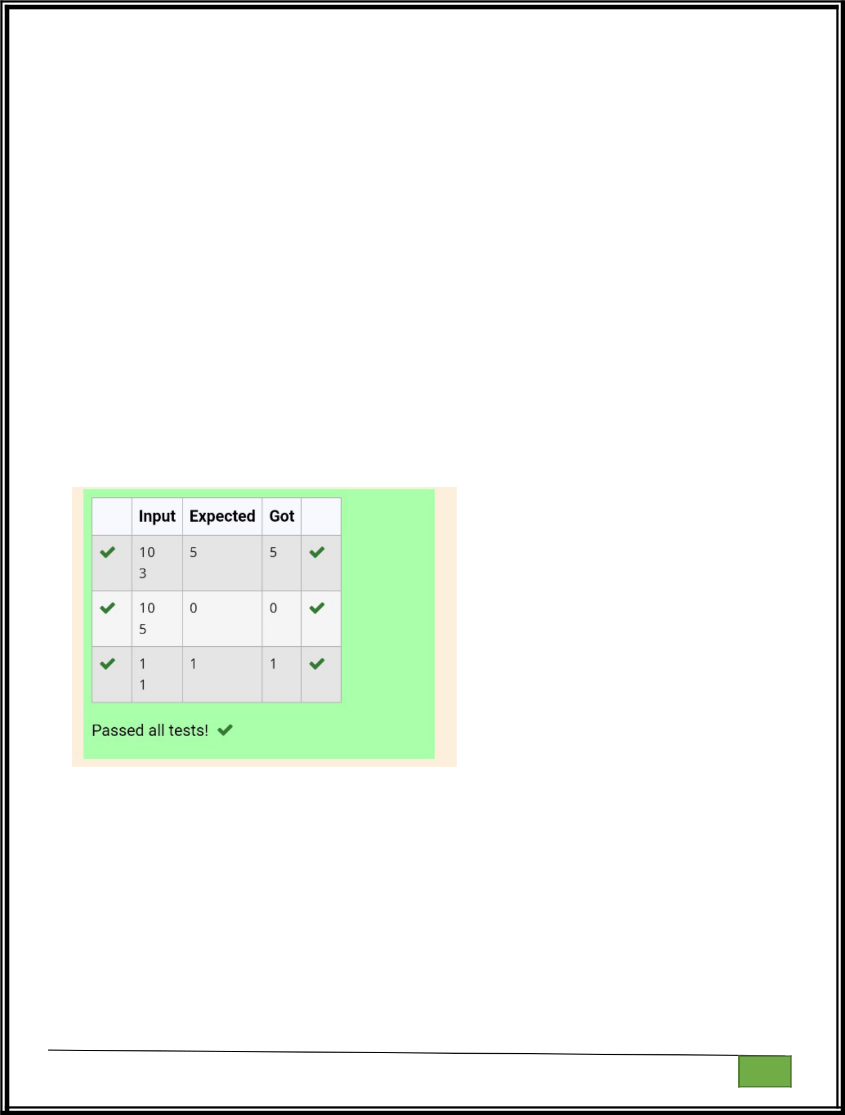
return 0

- Reading input directly from the standard input (typically for competitive programming)

input = sys.stdin.read

data = input().split()

n = int(data[0])

p = int(data[1])

- Calculate and print the p-th factor print(get_pth_factor(n, p))

Department of Computer Science and Engineering | Rajalakshmi Engineering College

PA.

GE

Department of Computer Science and Engineering

| Rajalakshmi Engineering College

PA. GE
Ex. No. : 5.7 Date: 25.04.2024

Register No.: 231401020 Name: BHUVANESWARI

Merge List

Write a Python program to Zip two given lists of lists.

Input:

m : row size

n: column size

list1 and list 2 : Two lists

Output

Zipped List : List which combined both list1 and list2 Sample test case

Sample input

2
2

1
3

5
7

2
4

6
8

Sample Output

[[1, 3, 2, 4], [5, 7, 6, 8]]

def zip_lists(list1, list2):

return [row1 + row2 for row1, row2 in zip(list1, list2)]

def main():

Department of Computer Science and Engineering | Rajalakshmi Engineering College

PA.

GE

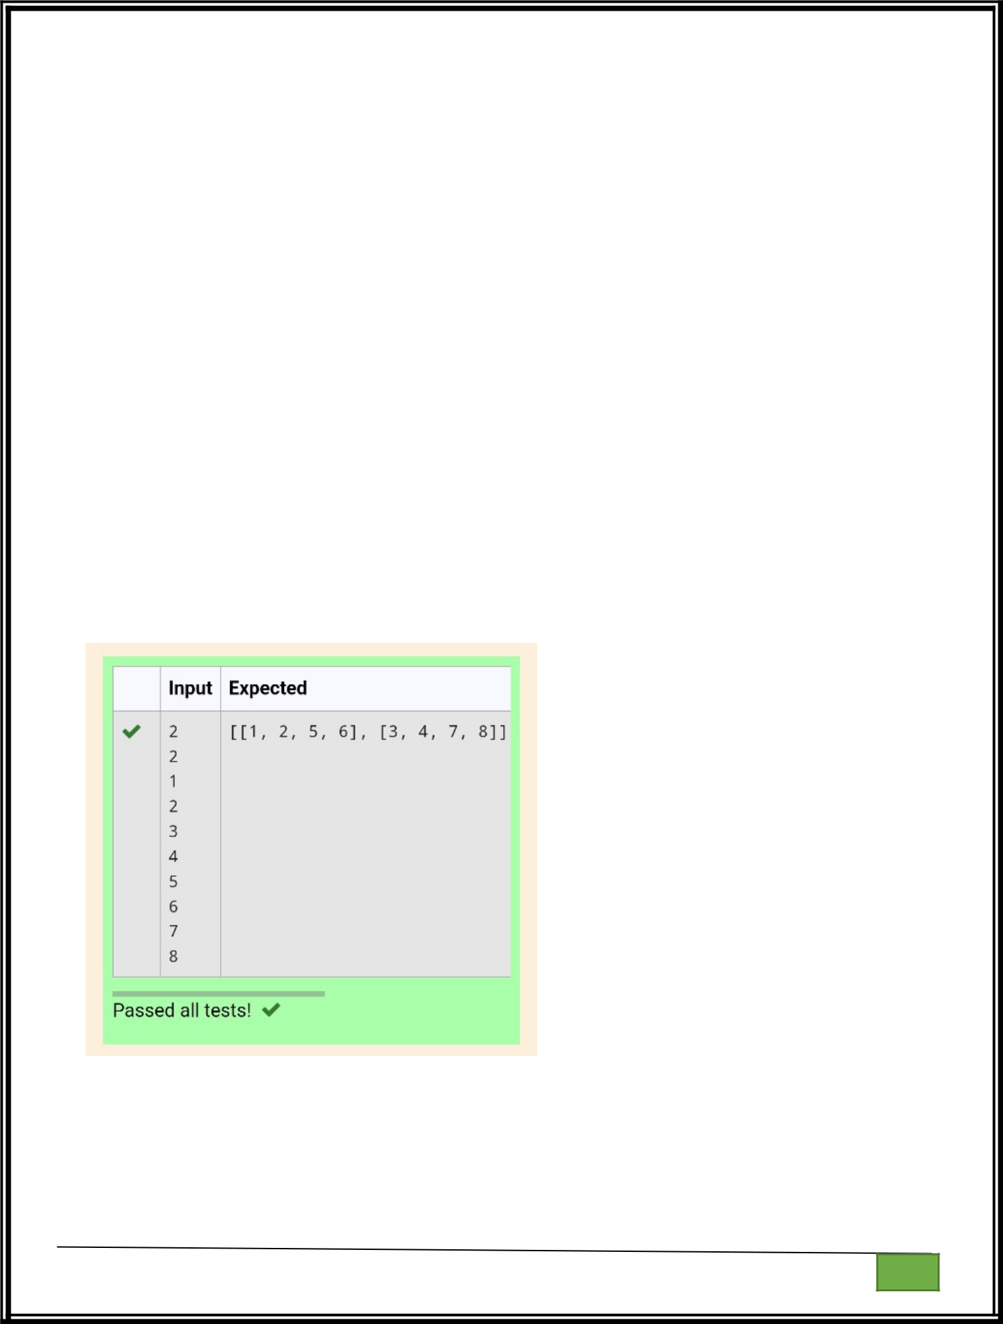
m = int(input())

n = int(input())

list1 = [[int(input()) for _ in range(n)] for _ in range(m)] list2 = [[int(input()) for _ in range(n)] for _ in range(m)]

zipped_list = zip_lists(list1, list2)

print(zipped_list)

if __name__ == "__main__":

main()

Department of Computer Science and Engineering

| Rajalakshmi Engineering College

PA. GE

Department of Computer Science and Engineering

| Rajalakshmi Engineering College

PA. GE
Ex. No. : 5.8 Date: 25.04.2024

Register No.: 231401020 Name: BHUVANESWARI

Merge Two Sorted Arrays Without Duplication

Output is a merged array without duplicates.

Input Format

N1 - no of elements in array 1

Array elements for array 1

N2 - no of elements in array 2

Array elements for array2

Output Format

Display the merged array

Sample Input 1

5
1

2
3

6
9

4
2

4
5

10

Sample Output 1

123456910

def merge_arrays_without_duplicates(arr1, arr2):

- Combine the arrays and convert to a set to remove duplicates result_set = set(arr1 + arr2)
- Convert the set back to a sorted list

Department of Computer Science and Engineering | Rajalakshmi Engineering College

PA.

GE

merged_sorted_array = sorted(result_set)

return merged_sorted_array

- Input read and processing def process_input():
  - Reading number of elements and the elements for the first array n1 = int(input())
array1 = []

for _ in range(n1): element = int(input()) array1.append(element)

  - Reading number of elements and the elements for the second array n2 = int(input())
array2 = []

for _ in range(n2): element = int(input()) array2.append(element)

  - Merge the arrays without duplicates

result = merge_arrays_without_duplicates(array1, array2)

# Print the result

print(" ".join(map(str, result)))

Department of Computer Science and Engineering | Rajalakshmi Engineering College

PA.

GE

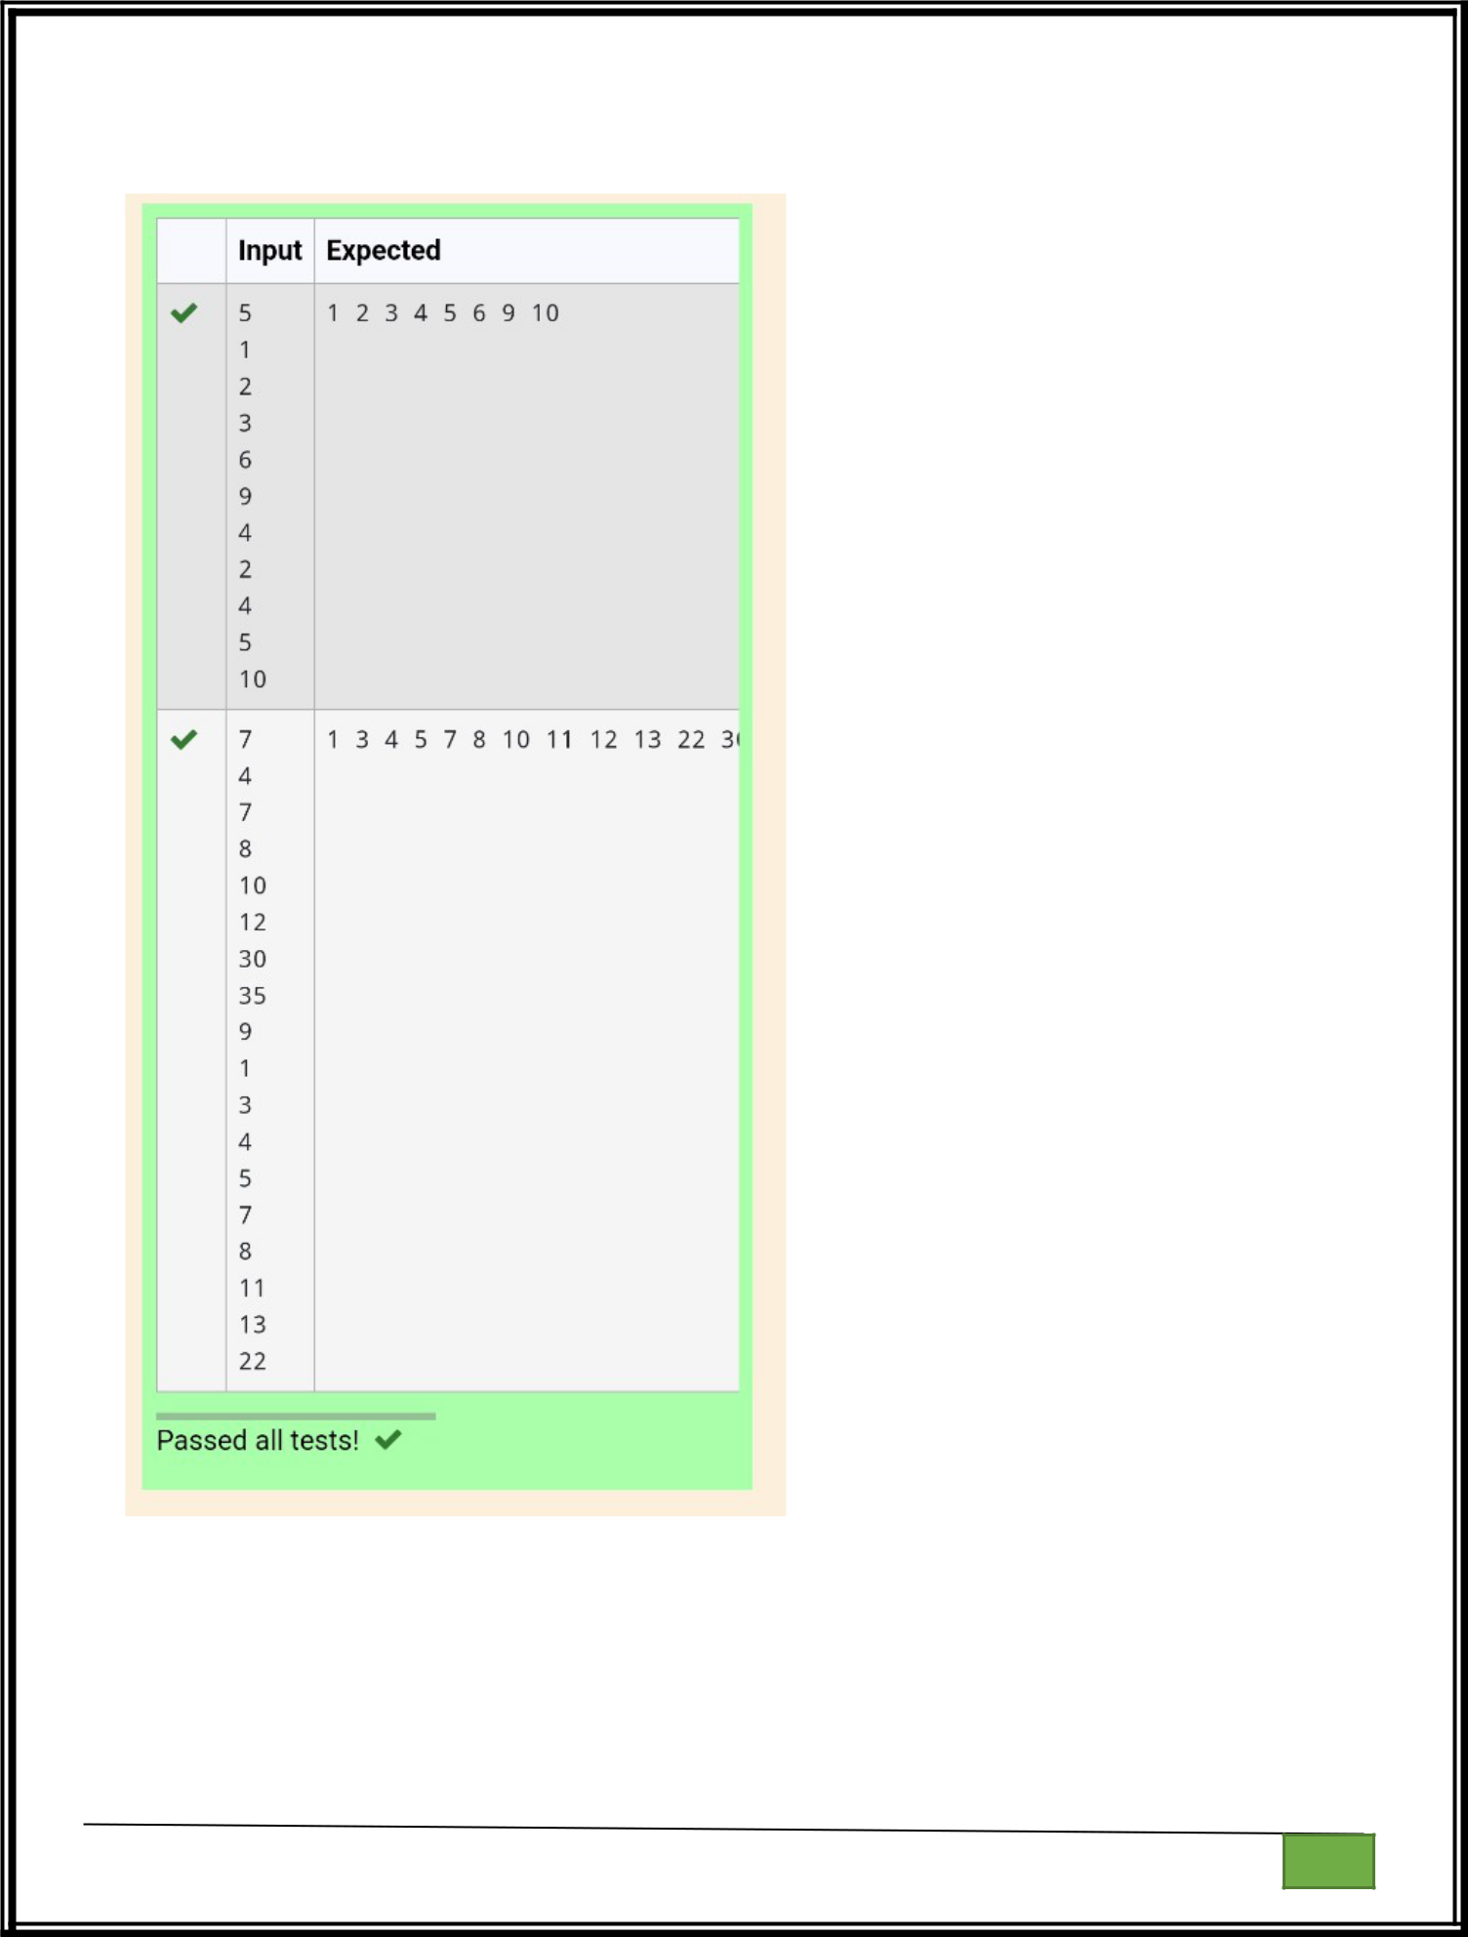

Department of Computer Science and Engineering

| Rajalakshmi Engineering College

PA. GE

Department of Computer Science and Engineering

| Rajalakshmi Engineering College

PA. GE
Ex. No. : 5.9 Date: 25.04.2024

Register No.: 231401020 Name: BHUVANESWARI

Print Element Location

Write a program to print all the locations at which a particular element (taken as input) is found in a list and also print the total number of times it occurs in the list. The location starts from 1.

For example, if there are 4 elements in the array:

5
6

5
7

If the element to search is 5 then the output will be:

5 is present at location 1
5 is present at location 3

5 is present 2 times in the array.
Sample Test Cases

Test Case 1

Input

4
5

6
5

7
5

Output

5 is present at location 1.

5 is present at location 3.
5 is present 2 times in the array.

Test Case 2

Input
5

67

Department of Computer Science and Engineering | Rajalakshmi Engineering College

PA.

GE

80
45

97
100

50

Output
50 is not present in the array.

def find_element_locations(lst, target):

locations = []

count = 0

for i in range(len(lst)):

if lst[i] == target:

locations.append(i + 1)

count += 1

return locations, count

def main():

n = int(input())

lst = [int(input()) for _ in range(n)]

target = int(input())

locations, count = find_element_locations(lst, target)

if count == 0:

print(f"{target} is not present in the array.")

Department of Computer Science and Engineering | Rajalakshmi Engineering College

PA.

GE

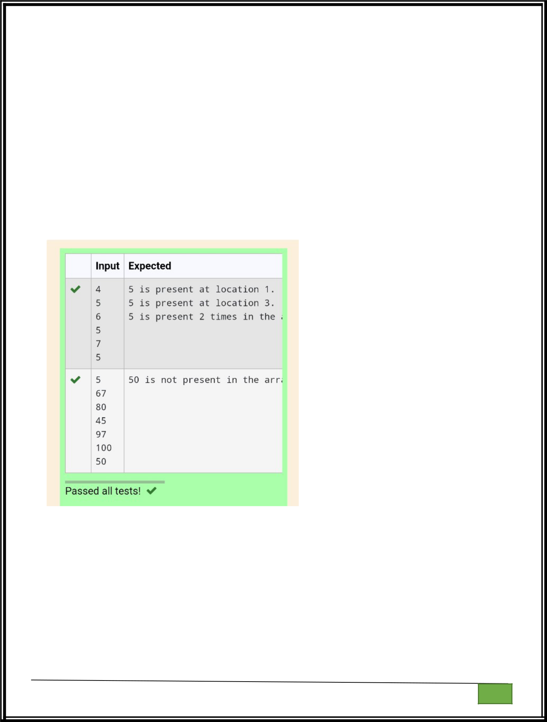
else:

for loc in locations:

print(f"{target} is present at location {loc}.")

print(f"{target} is present {count} times in the array.")

if __name__ == "__main__":

main()

Department of Computer Science and Engineering | Rajalakshmi Engineering College

PA.

GE

Department of Computer Science and Engineering

| Rajalakshmi Engineering College

PA. GE
Ex. No. : 5.10 Date: 25.04.2024

Register No.: 231401020 Name: BHUVANESWARI

Strictly increasing

Write a Python program to check if a given list is strictly increasing or not. Moreover, If removing only one element from the list results in a strictly increasing list, we still consider the list true

Input:
n : Number of elements

List1: List of values
Output

Print "True" if list is strictly increasing or decreasing else print "False"

Sample Test Case

Input

7

1

2

3

0

4

5

6

Output

True

n= int(input())

arr = [int(input()) for i in range(n)]

Department of Computer Science and Engineering | Rajalakshmi Engineering College

PA.

GE

l = arr.copy()

g=0

size = len(arr)

arr_asc = sorted(arr)

arr_des = sorted(arr)[::-1]

if arr==arr_asc or arr==arr_des:

print('True')

g=1

else:

for i in arr:

l.remove(i)

arr_asc.remove(i)

arr_des.remove(i)

if l==arr_asc or l==arr_des:

print('True')

g=1

break

l=arr.copy()

arr_asc = sorted(arr)

arr_des = sorted(arr)[::-1]

if g==0:

print('False')

Department of Computer Science and Engineering | Rajalakshmi Engineering College

PA.

GE

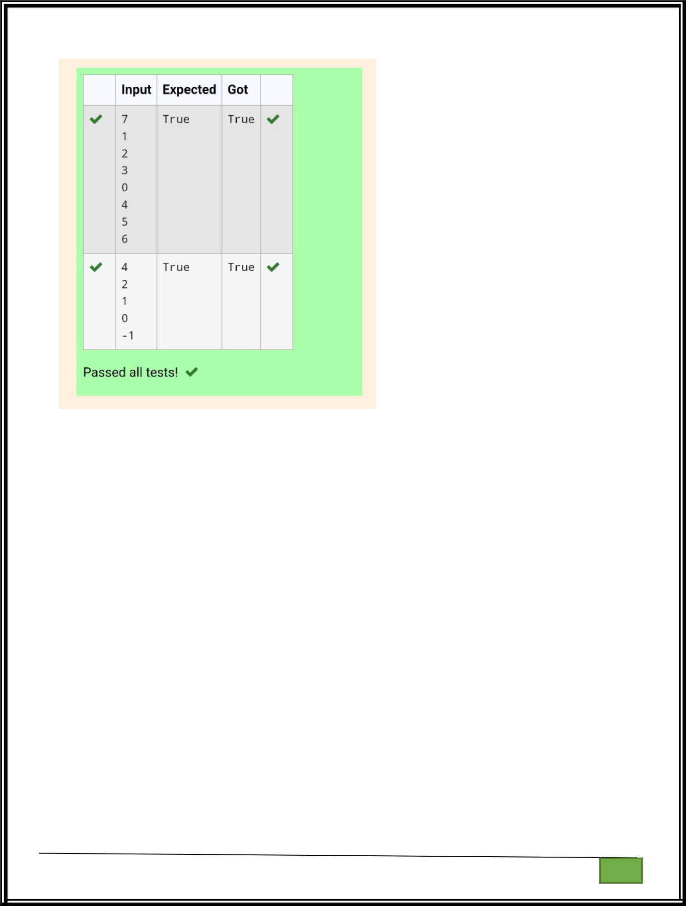

Department of Computer Science and Engineering

| Rajalakshmi Engineering College

PA. GE

Department of Computer Science and Engineering

| Rajalakshmi Engineering College

PA. GE

